

CoWork
(MINOR PROJECT – II)
SUBMITTED IN PARTIAL FULFILMENT OF THE REQUIREMENTS
FOR THE AWARD OF THE DEGREE
OF

MASTER OF COMPUTER APPLICATIONS (MCA) BY

Vaibhav Pathak (06911604425)

Devansh Patidar (09911604425)

Mayan Wadhawan (10811604425)

MCA – 2nd Semester

BHARATI VIDYAPEETH’S INSTITUTE OF
COMPUTER APPLICATIONS & MANAGEMENT (BVICAM)
GURU GOBIND SINGH INDRAPRASTHA UNIVERSITY, NEW DELHI
2026
CANDIDATE’S DECLARATION
We hereby declare that the work which is being presented in this project work entitled “CoWork ” in partial fulfilment of the requirements for the award of the degree of Master in Computer Applications at Bharati Vidyapeeth’s Institute of Computer Applications and Management (BVICAM), New Delhi is an authentic record of our own work carried out during the period July 2025 to December 2025 under the supervision and guidance of Dr. Sania Kukkar(Assistant Professor, BVICAM), Dr. Sunil Pratap Singh(Professor, BVICAM).
We have not submitted the matter embodied in this project work anywhere for the award of any degree or diploma.

Vaibhav Pathak (06911604425)

Devansh Patidar (09911604425)

Mayan Wadhawan ( 10811604425)

ACKNOWLEDGEMENT
It is our proud privilege to express our profound gratitude to the entire management of Bharati Vidyapeeth’s Institute of Computer Applications and Management and teachers of the institute for providing us with the opportunity to avail the excellent facilities and infrastructure. The knowledge and values inculcated have proved to be of immense help at the very start of our career. Special thanks to Hon’ble Founder, Bharati Vidyapeeth, Pune for having provided us an excellent infrastructure at BVICAM.

We are grateful to Dr. Sania Kukkar and Dr. Sunil Pratap Singh (Project Guides, BVICAM, New Delhi) for their astute guidance, constant encouragement and sincere support for this project work.

We feel pride and privileged in expressing our deep sense of gratitude to all those who have helped us in presenting this assignment. We would be failing in our endeavour if we did not place our acknowledgement.

Vaibhav Pathak (06911604425)

Devansh Patidar (09911604425)

Mayan Wadhawan ( 10811604425)

ABSTRACT
The “CoWork” project is a robust, full-stack web application designed to bridge the gap in the coworking industry by aggregating space providers and consumers into a single, transparent marketplace. Developed using ReactJS for the frontend, Java’s Spring Boot (4.0.6) for the backend, and MongoDB Atlas for cloud-based data management, the system provides a specialized platform that facilitates real-time price discovery through open competition. The application features a dual-purpose interface that enables users to effortlessly book workspaces while providing space owners with a comprehensive ERP (Enterprise Resource Planning) suite to manage their day-to-day operations and inventory.
The backend leverages the modern capabilities of Java 21, ensuring high performance and scalability for concurrent booking transactions and complex business logic. By utilizing MongoDB Atlas, the project benefits from a flexible, document-oriented database structure that handles diverse workspace metadata and geospatial search queries with high efficiency. The architecture follows a decoupled RESTful API design, ensuring seamless communication between the interactive ReactJS components and the secure Spring Boot services. This integration allows for a responsive, state-driven user experience where availability and pricing updates are reflected in real-time.
This project effectively demonstrates the application of modern software engineering principles, cloud database orchestration, and market-driven system design. It serves as a practical solution to current market fragmentation, showcasing how a unified digital ecosystem can drive efficiency and transparency in the flexible workspace sector. The system is built with modularity in mind, offering a scalable foundation for future enhancements such as AI-based pricing optimization, IoT smart access integration, and global multi-currency support.
TABLE OF CONTENTS
CHAPTER NO. | CHAPTER NAME | PAGE. NO
CHAPTER 1 | INTRODUCTION
1.1 | Problem Description
1.2 | Proposed Solution
1.3 | Team Structure and Role
1.4 | Deliverables
CHAPTER 2 | PROJECT DESCRIPTION
2.1 | System Specification
2.2 | Methodology used
2.3 | Modules and their Descriptions
CHAPTER 3 | FUNCTIONALITIES
3.1 | Use Case Diagram
3.2 | Data Flow Diagrams
3.3 | Entity-Relationship (E-R) Diagram
3.4 | Screenshots of the Running Project
3.5 | Advantages and Disadvantages of the System
CHAPTER 4 | CONCLUSION AND FUTURE SCOPE
CHAPTER 5 | BIBLIOGRAPHY

CHAPTER 1: INTRODUCTION

A.) Problem Description
The coworking industry has seen rapid growth, yet the market remains highly fragmented, leaving both space seekers and providers at a disadvantage. Currently, individuals looking for professional workspaces must navigate multiple, disconnected websites, often encountering outdated pricing or hidden fees. There is no centralized platform that facilitates open competition between space providers, which prevents users from achieving true price discovery. Furthermore, many coworking space owners lack an integrated, cost-effective tool to manage their day-to-day operations, lead tracking, and inventory within the same ecosystem where they list their spaces.
There is a clear need for a robust, cloud-integrated web application that bridges this gap by aggregating the coworking market and providing a seamless management interface for operators.
The existing problems can be summarized as:
- Market Fragmentation: Users must search multiple platforms to find and compare different coworking spaces, leading to an inefficient booking experience.
- Lack of Price Discovery: Without a platform that encourages open competition, consumers struggle to find the most competitive market rates for desks or cabins.
- Operational Overhead: Space providers often use separate, expensive, or complex ERP software to manage their inventory and bookings, which are not synced with their public listings.
- Real-time Data Gaps: Many existing directories suffer from stale data, lacking real-time availability and dynamic pricing updates.
To overcome these challenges, a full-stack web application is required that:
- Aggregates the Market: Uses a unified platform to host multiple coworking providers, allowing consumers to compare spaces side-by-side.
- Provides a Management ERP: Offers an integrated operational dashboard for space owners to manage bookings, inventory, and analytics.
- Leverages Modern Tech: Utilizes ReactJS for a responsive frontend and Java’s Spring Boot with Java 21 for a high-concurrency, scalable backend.
- Ensures Cloud Scalability: Uses MongoDB Atlas as a cloud-based DBMS to store flexible workspace metadata and handle geospatial search queries.
- Facilitates Booking: Provides a convenient and secure way for users to discover, facilitate, and confirm workspace bookings in real-time.

B.)Proposed Solution
The proposed solution is to develop CoWork, a robust, full-stack web application designed to serve as a centralized marketplace and management ecosystem for the coworking industry. The system is built using ReactJS for a dynamic frontend, Java’s Spring Boot (4.0.6) for a high-performance backend, and MongoDB Atlas as the cloud-based database. This solution aims to eliminate market fragmentation by aggregating space providers and consumers on a single platform, facilitating real-time price discovery and providing an integrated ERP suite for seamless operational management.

1. Unified Marketplace and Search Engine
The platform aggregates diverse coworking spaces into a searchable interface. Utilizing ReactJS, the frontend provides a responsive experience where users can filter spaces based on location, amenities, and capacity. This ensures that consumers can find a suitable place to work with minimal effort.

2. Real Price Discovery through Open Competition
By hosting multiple space providers on a single platform, the application fosters a competitive environment. Providers can adjust their listings in real-time, allowing users to compare costs and choose the most value-driven options, effectively solving the issue of opaque pricing in the current market.

3. Integrated Operations Management (ERP)
Beyond a simple listing site, the application provides space owners with a comprehensive dashboard to manage their daily operations. Built into the Spring Boot backend, this module allows providers to:
- Manage desk and cabin inventory.
- Track real-time occupancy and bookings.
- Generate revenue analytics and reports.
- Monitor member check-ins and operational logs.

4. Robust Backend with Java 21 and Spring Boot
The application leverages Java 21 to handle high-concurrency booking requests through modern threading models. The Spring Boot 4.0.6 framework facilitates the creation of secure, RESTful APIs, ensuring that data exchange between the marketplace and the database is fast, reliable, and secure.

5. Flexible Cloud Storage with MongoDB Atlas
Using MongoDB Atlas as a NoSQL database allows the platform to store varied workspace metadata (like Wi-Fi speed, coffee types, or ergonomic features) without a rigid schema. It also enables efficient Geospatial Indexing, allowing users to find the nearest coworking spaces based on their current GPS coordinates.

6. Seamless Interaction and State Management
The integration of ReactJS and Spring Boot ensures that the user interface remains in sync with the backend state. Whether a provider updates a price or a consumer confirms a booking, the changes are reflected across the platform instantly without requiring manual page refreshes.

How This Solution Solves the Problem
- Centralizes Fragmentation: Merges disconnected providers into one easy-to-use digital marketplace.
- Ensures Transparency: Drives down costs through open competition and visible market rates.
- Reduces Software Costs: Eliminates the need for providers to purchase separate, expensive management tools by offering an all-in-one ERP.
- Provides Real-time Accuracy: Uses a cloud-integrated database to ensure availability data is always current.
- Scalability: The use of Java 21 and MongoDB Atlas ensures the platform can scale from a few local spaces to a global network.

C).Team Structure and Role

1. Backend & Database Developer – Vaibhav Pathak
Role & Responsibilities:
- System Architecture: Designs and implements the server-side logic using Java 21 and Spring Boot 4.0.6.
- Database Management: Architectures the NoSQL document schema in MongoDB Atlas, ensuring efficient data storage for diverse workspace metadata.
- API Development: Builds secure, RESTful endpoints to facilitate seamless communication between the frontend and the database.
- Concurrency Handling: Implements high-performance booking logic, utilizing modern Java features like Virtual Threads to manage simultaneous transaction requests.
- Security & Integration: Configures Spring Security and JWT for user authentication and role-based access control.

2. Frontend Developer – Devansh Patidar
Role & Responsibilities:
- UI/UX Design: Designs and develops the user interface using ReactJS, focusing on a clean, modern, and intuitive user experience.
- Component Architecture: Creates reusable React components for the marketplace search engine and the provider’s ERP dashboard.
- State Management: Manages dynamic data flows, ensuring that real-time availability and price discovery updates are reflected without page refreshes.
- API Consumption: Integrates backend REST services into the frontend, handling asynchronous data fetching and error states.
- Responsive Layouts: Ensures the application is fully responsive and functional across various devices and screen sizes.

3. Research, Documentation & Report – Mayan Wadhawan
Role & Responsibilities:
- Market Research: Conducts in-depth research on the coworking market to refine the "Real Price Discovery" and "Open Competition" logic.
- Technical Documentation: Prepares all structured project documentation, including the Abstract, Problem Statement, and Proposed Solution.
- Diagram Design: Develops and explains technical diagrams such as Data Flow Diagrams (Level 0 & 1) and system architecture charts.
- Report Compilation: Organizes and compiles the final project report, ensuring all technical specifications and screenshots are professionally presented for submission.
- Quality Assurance: Reviews the project requirements to ensure the final implementation aligns with the initial objectives and user-centric goals.

D). Deliverables (Short Version)
- Working Web Application
- A fully functional, responsive full-stack platform for coworking space aggregation, booking, and operational management.
2. MongoDB Atlas Database
- A cloud-hosted database containing optimized collections for Users, Workspace listings, Bookings, and Dynamic Pricing records.
3. Project Source Code
- The complete source repository, including modularized ReactJS frontend components and the Java Spring Boot backend logic.
4. Project Documentation & Report
- Comprehensive documentation covering the project Abstract, Problem Statement, Technical Specifications, and Implementation conclusions.
5. System Design Diagrams
- Visual representations of the system, including DFD Levels 0 & 1, Database Schema design, and Architecture flowcharts.
6. User Interface & ERP Screenshots
- High-resolution captures of the Consumer Marketplace (Discovery), the Booking Flow, and the Provider’s Management Dashboard (ERP).
7. Deployment & Build Artifacts
- The compiled Spring Boot JAR file, production-ready React build files, and a detailed README for environment setup and API execution.

CHAPTER – 2 PROJECT DESCRIPTION

A). System Specification

i. Hardware Requirements
- Processor: Dual Core / i3 or higher
- RAM: Minimum 4 GB
- Storage: At least 500 MB free space
- Display: 1024 × 768 resolution or higher
- Input Devices: Keyboard and mouse

ii. Software Requirements
- Operating System: Windows / Linux
- IDE(used):
  - VSCodium / IntelliJ IDEA
- Programming Language:
  - Java (JDK 8 or above)
  - JavaScript (ReactJS)
- Database:
  - MongoDB Atlas
- Browser:
  - Any modern browser (for documentation reference only)

B). Methodology Used
The development of the system followed the Software Development Life Cycle (SDLC). The major phases applied in this project are:

1. Requirement Analysis
In this phase, all functional and non-functional requirements were collected.
Key needs identified were:
- A centralized marketplace for coworking space discovery.
- A real-time price discovery engine based on open competition.
- An integrated ERP system for space providers to manage operations.
- Scalable cloud storage and high-concurrency backend support.
- Version Control: Git/GitHub was used for collaborative development and code management.

2. System Analysis and Design
This phase involved planning the technical architecture to ensure seamless communication between the frontend and backend.
Activities included:
- Designing the NoSQL document schema for MongoDB Atlas.
- Preparing system diagrams including DFD Levels 0 & 1 and Architecture flows.
- Planning the RESTful API structure for stateless communication.
- Designing the UI/UX wireframes for the marketplace and the provider dashboard using ReactJS principles.

3. Coding / Implementation
The actual development of the full-stack application was carried out during this phase using modern programming standards.
Tasks performed:
- Developing the interactive UI using ReactJS and managing component states.
- Building the robust backend using Java 21 and Spring Boot 4.0.6.
- Implementing Java Virtual Threads to handle high-concurrency booking requests.
- Configuring MongoDB Atlas for cloud data persistence and geospatial indexing.
- Integrating the frontend with backend REST services.

4. Testing
After coding, the application underwent rigorous testing to ensure stability and transactional integrity.
Testing included:
- API Testing: Using tools like Postman to verify REST endpoints.
- Integration Testing: Ensuring the React frontend correctly renders data from MongoDB via Spring Boot.
- Concurrency Testing: Verifying that the booking engine handles simultaneous users without errors.
- UI/UX Testing: Checking responsiveness across different screen sizes and browsers.

5. Implementation / Deployment
In the final phase, the complete system was prepared for production and user access.
Deliverables included:
- Creating the final production build for the ReactJS frontend.
- Packaging the Spring Boot backend into a runnable JAR file.
- Configuring cloud environment variables for MongoDB Atlas connectivity.
- Compiling the final technical documentation and system screenshots.

C). Modules and Their Descriptions
The system is architected into several modular components across the ReactJS frontend and Spring Boot backend, each responsible for a specific domain of the application. The major modules are:

1. Security & Auth Module (Spring Security & JWT)
This backend module serves as the gatekeeper of the application. It utilizes Spring Security to handle user registration, login, and encrypted password storage.

2. Space Discovery Module (React & Spring Boot)
This module facilitates the "Marketplace" experience. On the frontend, it provides a dynamic search interface with filters. On the backend, it interacts with MongoDB Atlas using geospatial queries to fetch coworking spaces

3. Booking & Transaction Module (Java 21 Services)
Responsible for the core business logic of the application, this module manages the lifecycle of a reservation. It leverages Java 21’s Virtual Threads to handle high volumes of concurrent booking attempts.

4. Provider ERP Dashboard (React Components)
A specialized frontend module designed specifically for space owners. It consists of a suite of data-intensive components—including tables and charts—that allow providers to manage their day-to-day operations.

5. Repository Layer (Spring Data MongoDB)
This backend module acts as the data access abstraction layer. It uses Spring Data MongoDB to perform CRUD operations on the cloud-based DBMS. It maps Java POJOs (Plain Old Java Objects) to MongoDB documents.

6. Dynamic Pricing Engine (Spring Boot Logic)
This is the "Price Discovery" heart of the platform. It contains algorithms that monitor market demand and provider inputs to update listing prices.

7. API Gateway & Controller Layer (Spring RestControllers)
This module defines the RESTful endpoints of the system. It handles incoming HTTP requests from the React application, validates the input data, and routes the request to the appropriate service module

CHAPTER – 3 FUNCTIONALITIES

A).Use Case Diagram

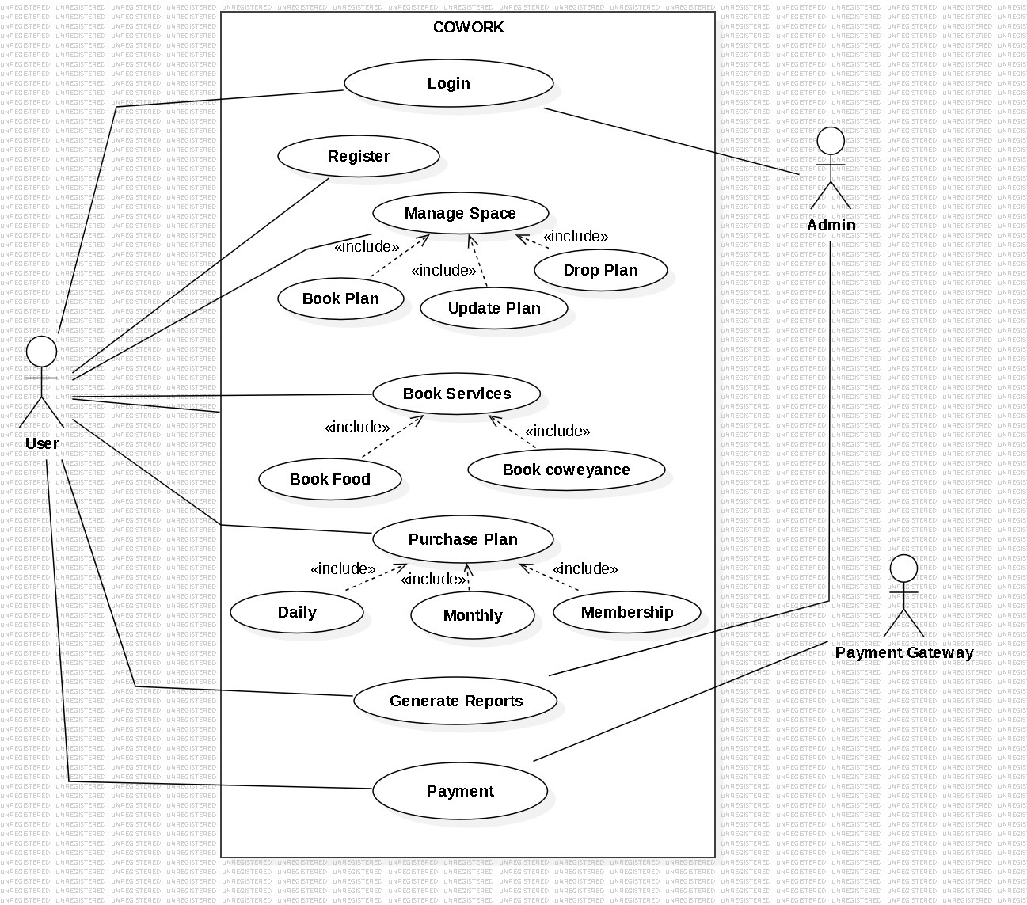

B.)Data Flow Diagrams (Level 0 and Level 1)

LEVEL- 0

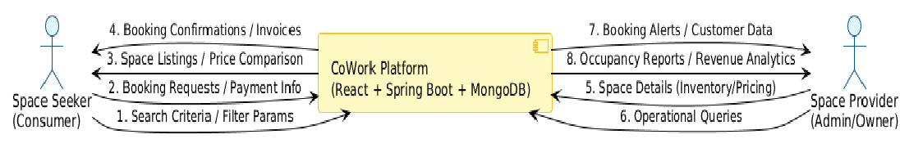
LEVEL 1

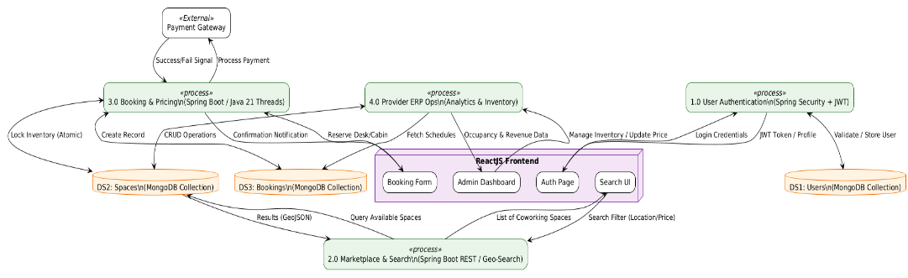
C). Entity-Relationship (E-R) Diagram
Email
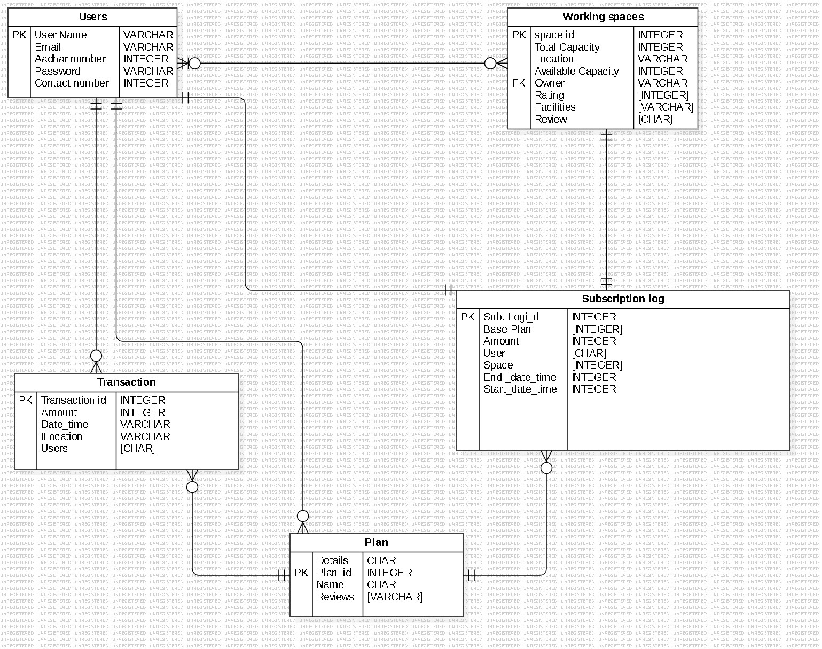

D). Screenshots of the Running Project

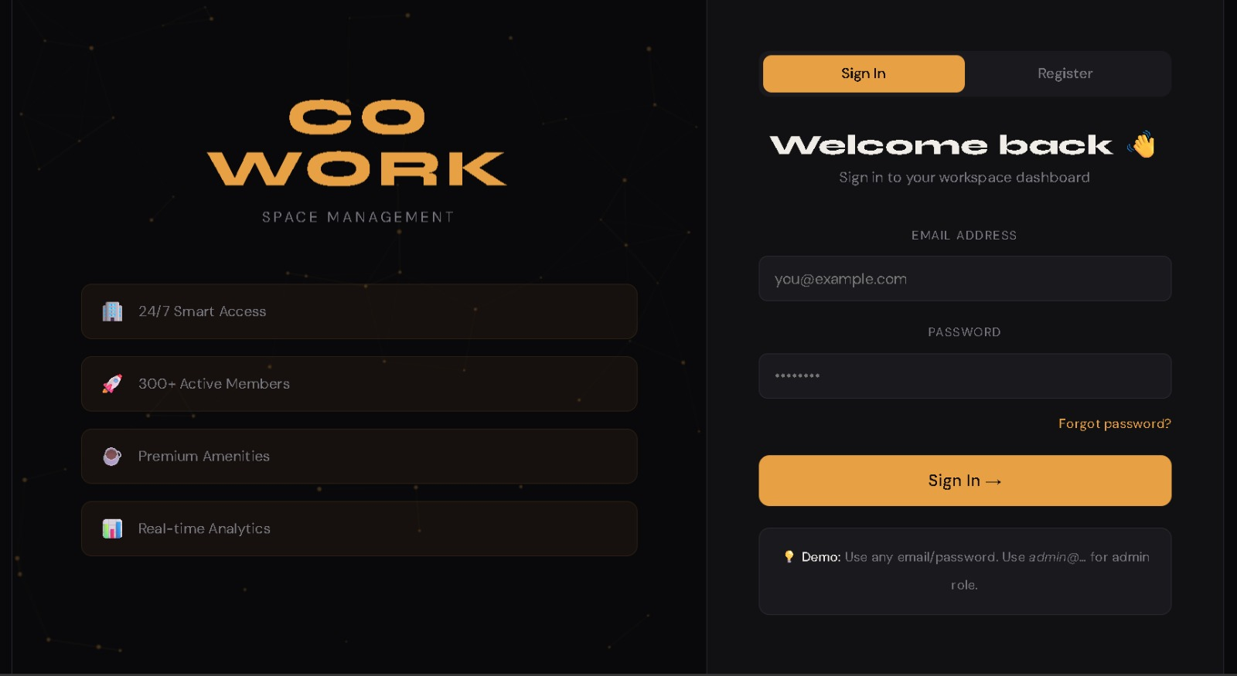
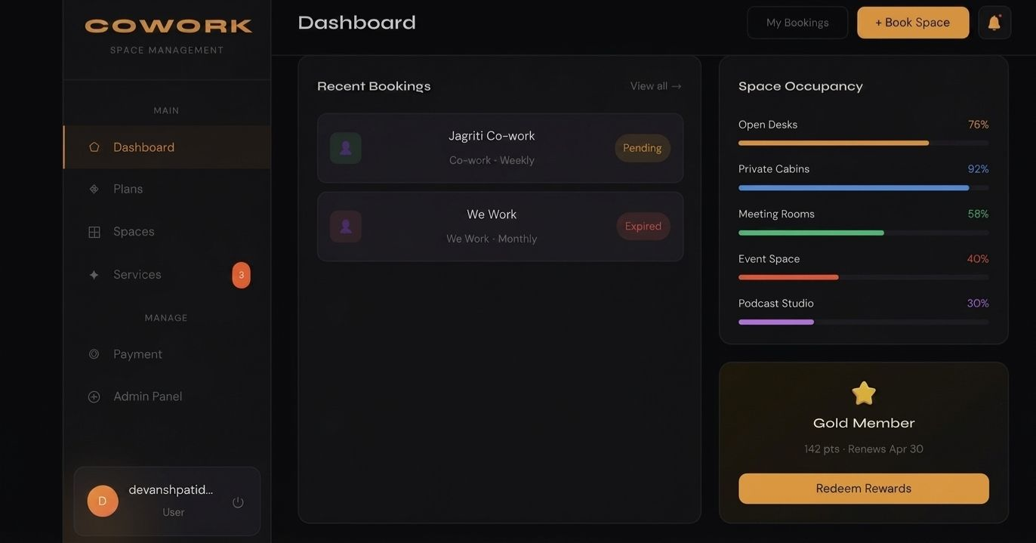
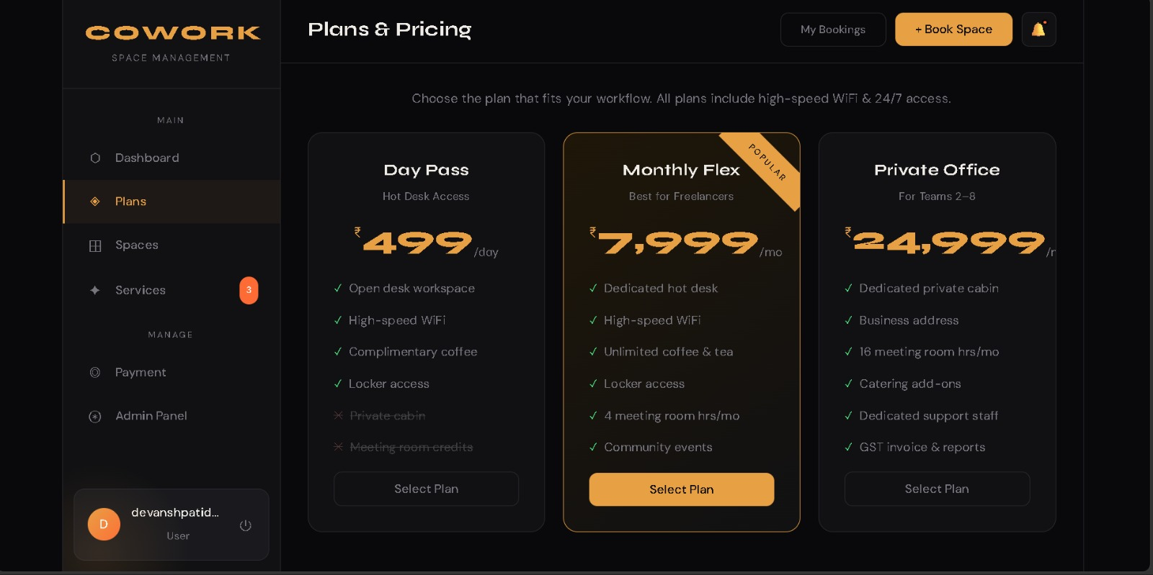

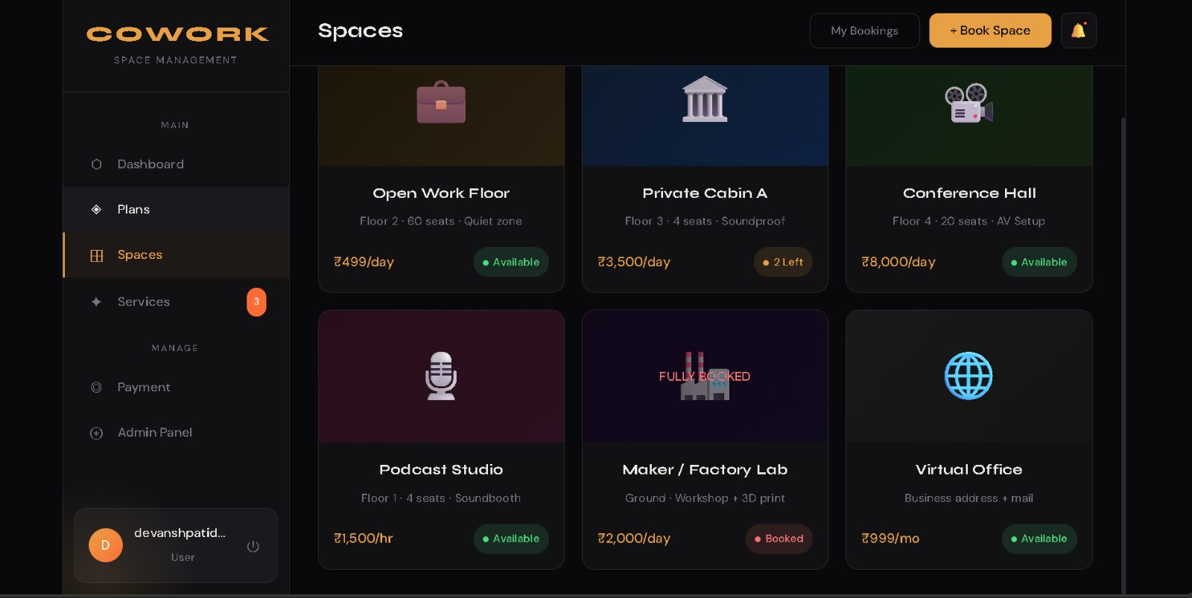
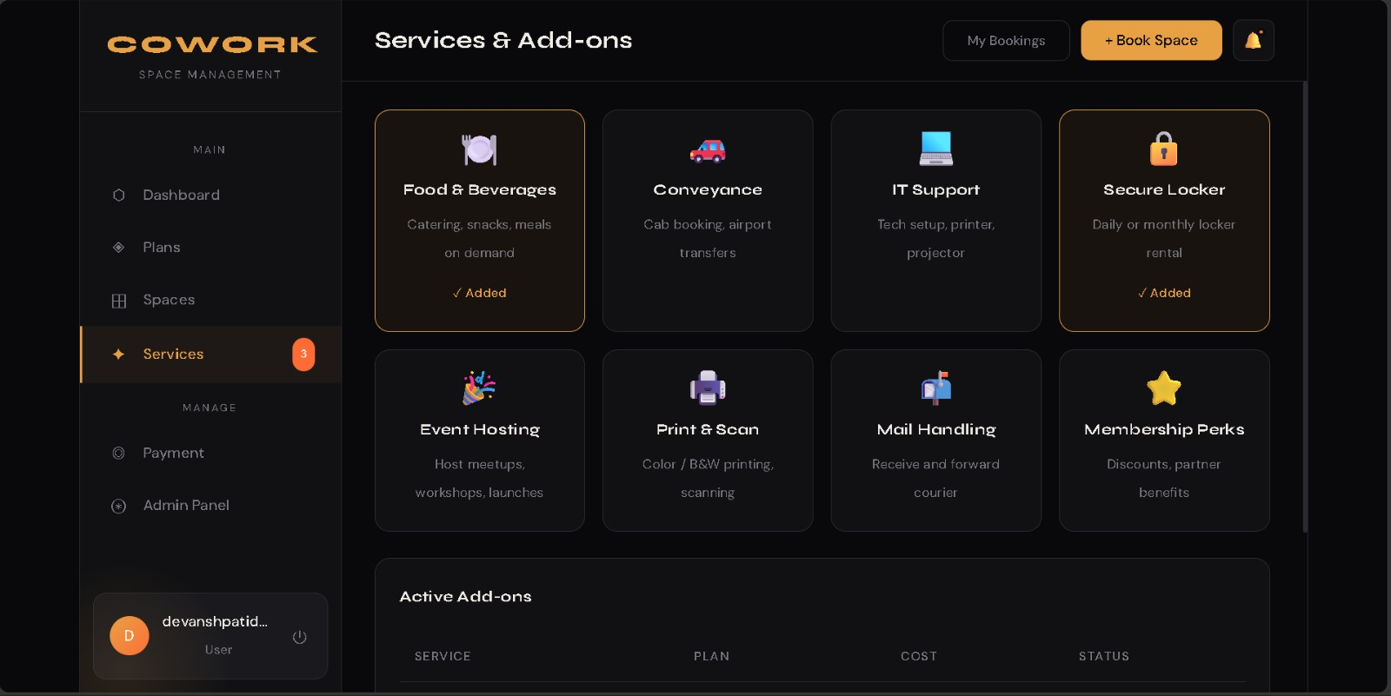
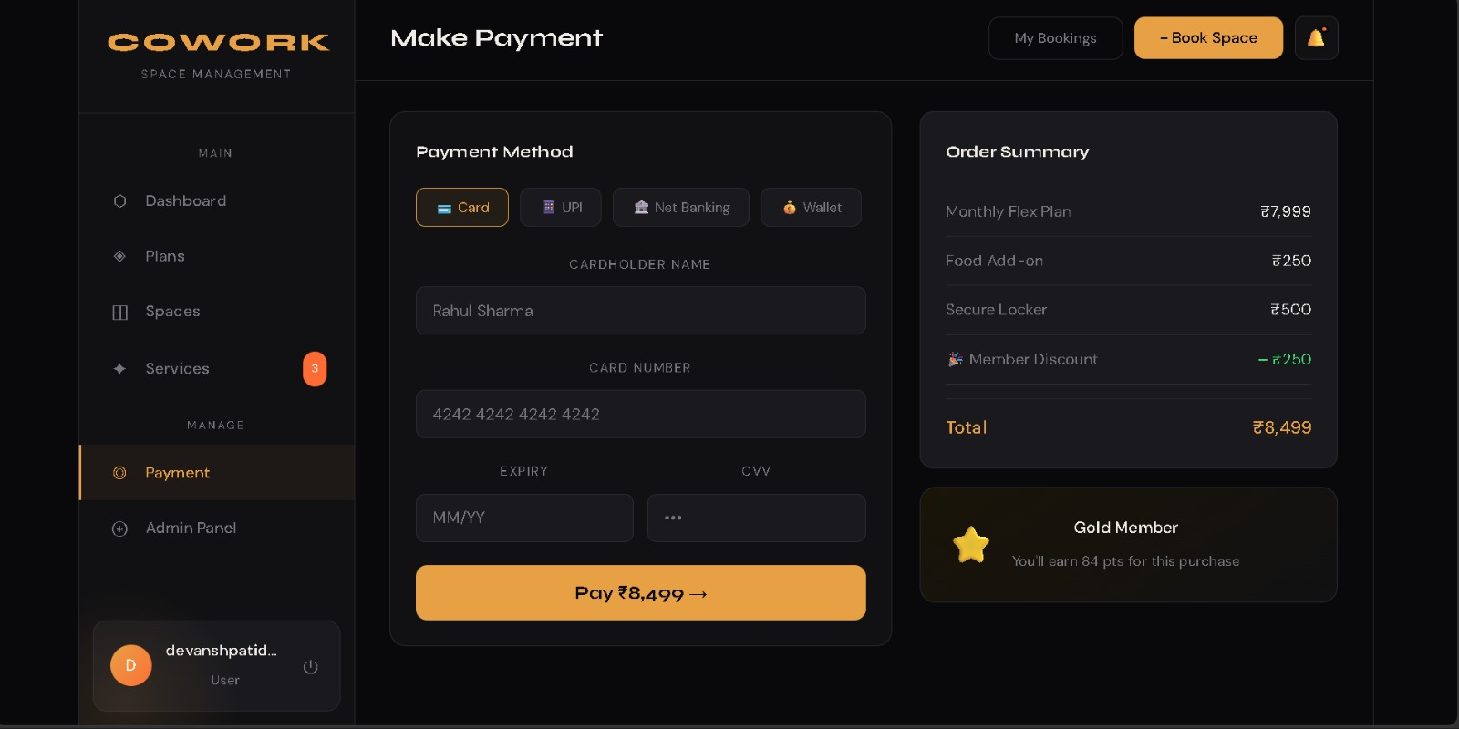
E).Advantages and Disadvantages of the System
Advantages
- Real-Time Price Discovery:
By aggregating multiple providers, the system fosters open competition, allowing users to find the most competitive market rates instantly.
- High Concurrency & Performance:
Leveraging Java 21’s Virtual Threads ensures the backend remains responsive even during high volumes of simultaneous booking requests.
- Integrated ERP Functionality:
Space providers save on costs and complexity by using a built-in suite for day-to-day operations rather than third-party software.
- Cloud Scalability & Reliability:
The use of MongoDB Atlas ensures that the data is accessible globally with high availability and automated scaling.
- Flexible Data Structure:
A NoSQL approach allows for varied coworking amenities (like different meeting room tech or cafe options) to be stored without rigid schema constraints.
- Modern User Experience:
The ReactJS frontend provides a fast, state-driven interface that updates dynamically without the need for manual page refreshes.

Disadvantages
- Internet Dependency:
Unlike offline applications, the system requires a stable internet connection to access the cloud database and real-time listings.
- Data Consistency Challenges:
In a high-speed marketplace, maintaining absolute real-time synchronization of "last-minute" desk availability can be complex.
- Initial Provider Onboarding:
The system’s value depends on a high number of providers; the platform faces a "cold start" challenge in new geographic regions.
- Complexity of Management:
A full-stack architecture (React-Spring-MongoDB) is more difficult to maintain and debug compared to simpler monolithic desktop applications.
- Potential Latency:
As a cloud-based system, users in regions with poor connectivity may experience latency when fetching high-resolution images of workspaces.

CHAPTER- 4
CONCLUSION AND FUTURE SCOPE

CONCLUSION

The CoWork platform, developed using ReactJS, Java’s Spring Boot, and MongoDB Atlas, successfully demonstrates how a robust, full-stack web application can modernize the fragmented coworking industry. The primary goal of the project was to create a centralized marketplace that empowers users through real-time price discovery while providing space providers with an integrated, efficient ERP tool to manage their operations. Throughout the development process, modern software engineering principles, cloud database orchestration, and high-concurrency programming techniques were effectively applied, resulting in a scalable and high-performance solution.
The choice of MongoDB Atlas as the cloud-based DBMS ensured a flexible data model capable of handling diverse workspace metadata and geospatial searches, making the platform adaptable to various market needs. The implementation of Spring Boot 4.0.6 and Java 21 allowed for secure, stateless communication via RESTful APIs and ensured the system could handle intensive booking traffic through advanced threading models. Simultaneously, ReactJS provided a dynamic and responsive graphical interface, allowing both seekers and providers to interact with the marketplace and management dashboard seamlessly.
This project also demonstrates industry-standard development practices, including role-based access control (RBAC) with JWT, modular backend services, and a decoupled architecture that separates business logic from the user interface. Features such as the competitive pricing engine and integrated inventory management show how digital transformation can drive transparency and operational efficiency in a real-world business context.
In conclusion, the project fulfills all its core objectives and stands as a practical example of a sophisticated, market-ready web application. It showcases how core programming, cloud-native database management, and modern frontend frameworks can be integrated to create a meaningful, user-centric ecosystem. The system is robust, reliable, and highly scalable, serving as a powerful foundation for future enhancements such as AI-driven occupancy forecasting and global expansion.

FUTURE SCOPE
- AI-Driven Dynamic Pricing:
The system can be enhanced with machine learning algorithms to suggest optimal pricing for space providers based on historical occupancy trends and real-time local demand.
- IoT and Smart Access Integration:
Integration with smart hardware for automated check-ins via QR codes or NFC and real-time energy management (lighting/AC) within booked cabins.
- Mobile Application Development:
Expanding the ecosystem into native Android and iOS applications using React Native to provide on-the-go booking and push notification alerts for users.
- Virtual Reality (VR) Space Tours:
Incorporating 360-degree virtual tours and Augmented Reality (AR) features to allow seekers to visualize the workspace environment before making a booking.
- Blockchain for Secure Transactions:
Implementing smart contracts to handle automated micro-payments and transparent, immutable records of lease agreements between providers and long-term tenants.
- Advanced Community Features:
Adding networking modules that allow users to connect with other professionals working in the same space, fostering a collaborative ecosystem within the platform.
- Global Expansion and Multi-Currency Support:
Scaling the architecture to support multiple languages and international payment gateways, facilitating seamless cross-border workspace bookings.

CHAPTER- 5 Bibliography

Books & Study Material
- Spring Boot in Action – Craig Walls
- MongoDB: The Definitive Guide – Shannon Bradshaw, Eoin Brazil, and Kristina Chodorow
- Clean Architecture: A Craftsman's Guide to Software Structure and Design – Robert C. Martin
- Modern Java in Action: Lambdas, Streams, Reactive, and Java 12-17 Programming – Raoul-Gabriel Urma
Official Documentation
- Spring Boot Documentation – https://spring.io/projects/spring-boot
- React Official Documentation – https://react.dev
- MongoDB Atlas Documentation – https://www.mongodb.com/docs/atlas
- Java 21 SE Platform Documentation – https://docs.oracle.com/en/java/javase/21

Online Resources
- Baeldung – Comprehensive guides on Spring Boot and Spring Security
- FreeCodeCamp – Tutorials on ReactJS and Full-Stack development
- GeeksforGeeks – REST API design patterns and Java concurrency tutorials
- Stack Overflow – Technical troubleshooting and community-driven coding references

Additional References
- JSON Web Token (JWT) Official Guide – https://jwt.io/introduction
- Postman API Documentation – Guidelines for testing RESTful services
- Coworking Industry Reports – Research on market fragmentation and price discovery trends for functional requirements

_________________________________

